SMART SOLUTION FOR RAILWAYS

TEAM ID:PNT2022TMID35794

SPRINT-2: DASHBOARD:

NODE RED:

BACK-END SCREENSHOTS:
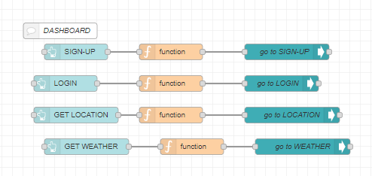
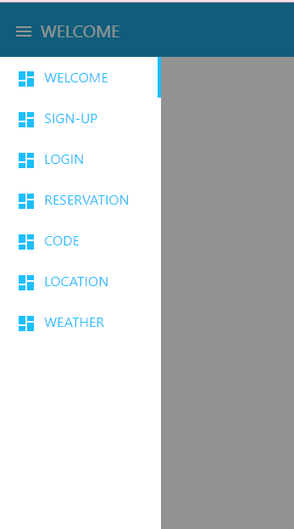
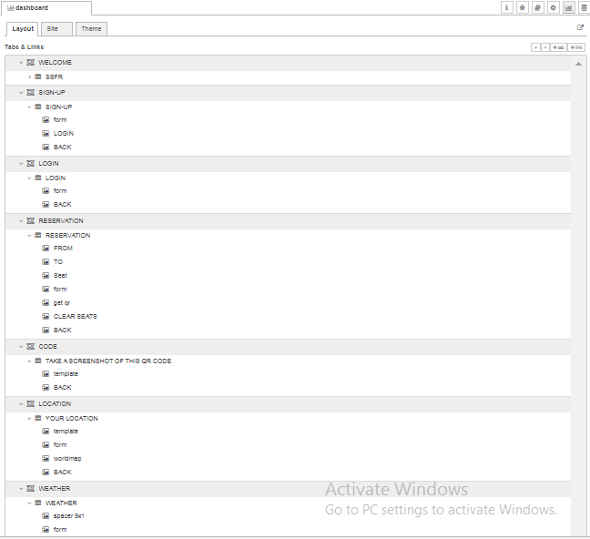

WELCOME SCREEN:
